ISI Project

Online Shopping Mall

Supervisor: Calana Chan

Team leader: Derek Dong

Team member: Bowie Liu

Franz Fang

1. Project Scope

Functional requirements:

Product list: A1, A2, A3, A5, A6

Customer account management: B1, B2

Shopping cart: C1, C2, C3, C4, C5

Purchase tracking: D1, D2, D3

Product catalog maintenance: E1, E2

Purchase orders processing: F1, F2, F3, F4

Advanced features: Z1, Z3, Z4

1. Time schedule

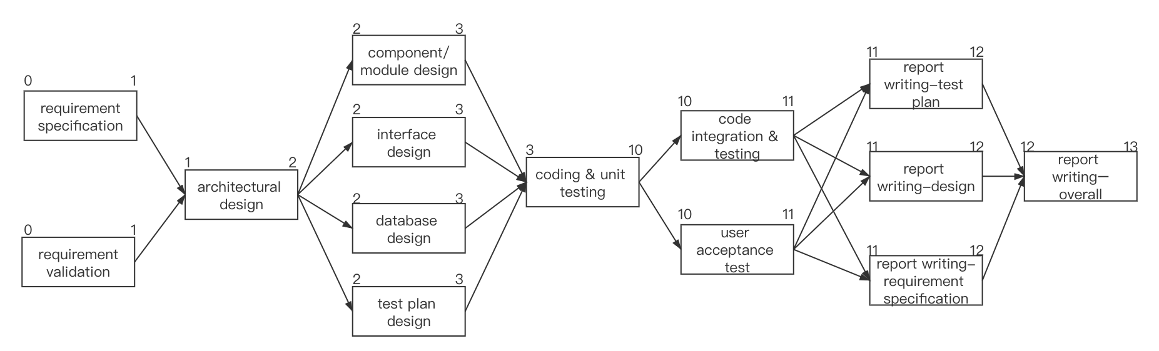

|  |  |  |
| --- | --- | --- |
|  | Task | Duration (week) |
| A | requirement specification | 1 |
| B | requirement validation | 1 |
| C | architectural design | 1 |
| D | component/module design | 1 |
| E | database design | 1 |
| F | interface design | 1 |
| G | coding & unit testing | 7 |
| H | code integration & testing | 1 |
| I | test plan design | 1 |
| J | user acceptance test | 1 |
| K | report writing-requirement specification | 1 |
| L | report writing-design | 1 |
| M | report writing-test plan | 1 |
| N | report writing–overall | 1 |

Milestone (event completed):

requirement validation

database design

coding & unit testing

user acceptance test

report writing–overall

WBS

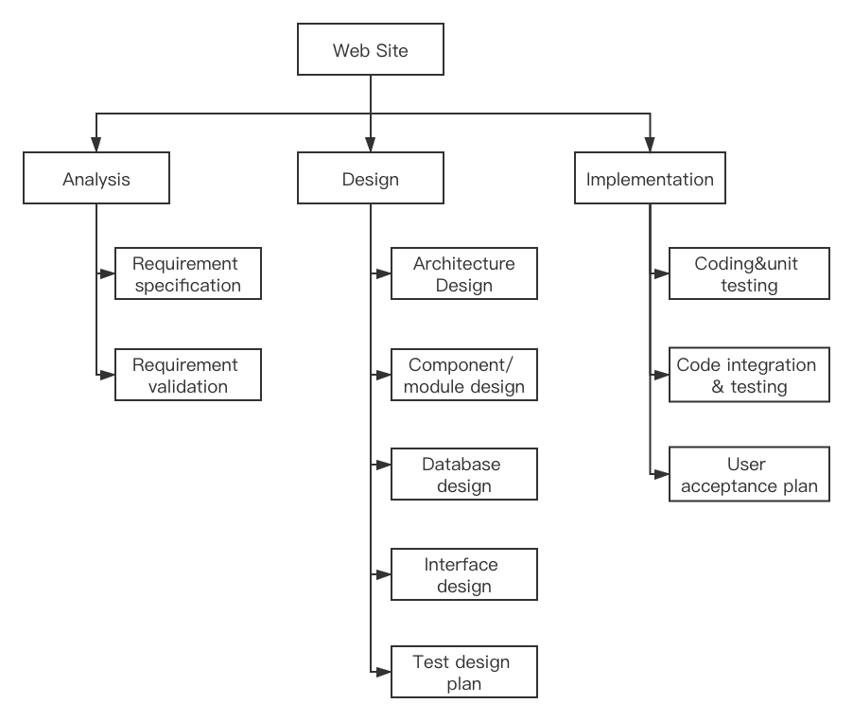

1. Job distribution

|  |  |
| --- | --- |
| Date | Job Distribution |
| Week1 | Derek: finish the work plan and design the ER diagram. Bowie: finish the schema. Franz: join in the discussion. |
| Week2 | Complete the database design, architecture design and component/module design. |
| Week3 | Finish at least 6 basic functions totally.  Make unit testing for each one. |
| Week4 | Finish at least 3 basic functions totally.  Make unit testing for each one. |
| Week5 | Finish at least 3 basic functions totally.  Make unit testing for each one. |
| Week6 | Finish at least 3 basic functions totally.  Make unit testing for each one. |
| Week7 | Finish at least 3 basic functions totally.  Make unit testing for each one. |
| Week8 | Finish at least 3 basic functions totally.  Make unit testing for each one. |
| Week9 | Integrate all the basic functions, make unit testing and integrated testing. |
| Week10 | Finish advanced features (Z1, Z3, Z4) |
| Week11 | Finish advanced features (Z1, Z3, Z4) |
| Week12 | Derek: finish report (writing-design)  Bowie: finish report (writing-test plan)  Franz: finish report (writing-requirement specification) |
| Week13 | Complete report (writing-overall) |
| Week14 | Derek: Finish PPT and Demo  Bowie: Finish PPT and Demo  Franz: Finish PPT |

According to the basic functional tasks

Derek: A1, A2, A3, A5, A6 and E1, E2

Bowie: D1, D2, D3 and F1, F2, F3, F4

Franz: B1, B2 and C1, C2, C3, C4, C5

According to the advanced features

Derek: Z3

Bowie: Z4

Franz: Z1